A MINI PROJECT REPORT ON

“Decentralized Voting System”

SUBMITTED TO THE SAVITRIBAI PHULE PUNE UNIVERSITY,
PUNE IN THE PARTIAL FULFILLMENT OF THE REQUIREMENTS FOR THE AWARD OF THE DEGREE
OF
Computer Engineering

SUBMITTED BY
(Class – BE A, Batch – B1)
Neeti Kurulkar

UNDER THE GUIDANCE OF
Ms. Pooja Hande


COMPUTER ENGINEERING
P.E.S MODERN COLLEGE OF ENGINEERING
PUNE – 411005.
SAVITRIBAI PHULE PUNE UNIVERSITY
[2024-25]


Progressive Education Society’s
Modern College of Engineering
Shivajinagar, Pune: 411005.

CERTIFICATE

This is to certify that the following students of Computer Engineering of PES’s, Modern College of Engineering have successfully completed their mini project and design of project entitled “Decentralized Voting System” under the guidance of the course instructor.
The Group Members are:
Roll Number | Name
31003 | Komal Ambhore
31018 | Tejal Dhoot
31020 | Shrey Doshi
31040 | Neeti Kurulkar
31071 | Soham Sarade

This is in partial fulfillment of the award of the degree Computer Engineering of Savitribai Phule Pune University.

Date:

Ms. Pooja Hande Prof. Dr. Mrs. S. A. Itkar
Course Instructor H.O.D
Department of Computer Engineering

ACKNOWLEDGEMENT

We would like to express our sincere gratitude to Ms. Pooja Hande, our project guide, for her consistent guidance, technical insights, and constructive feedback throughout the development of our mini project, “Decentralized Voting System”. Her expertise in Blockchain technology has been instrumental in shaping the project and ensuring its successful completion.

We are also thankful to Prof. Dr. Mrs. S. A. Itkar, Head of the Department, for providing us with the academic resources and a conducive environment that enabled us to undertake and complete this project effectively.

We acknowledge the support of the Department of Computer Engineering, Progressive Education Society’s Modern College of Engineering, for facilitating access to the required tools and infrastructure during this project.

Lastly, we extend our appreciation to all faculty members and peers whose timely inputs and suggestions contributed to the improvement and refinement of our work.

Table of Contents

ABSTRACT 1
Introduction 2
1.1 Overview: 3
Objectives 5
Motivation 7
3.1 Motivation: 8
Scope 9
System 11
Architecture 11
System 13
Specifications 13
Results 16
Conclusion 19
References 21

ABSTRACT

The Decentralized Voting System is a blockchain-based web application designed to ensure transparency, security, and fairness in the voting process. Traditional voting systems often face challenges such as vote tampering, lack of transparency, and limited accessibility. This system leverages the immutability and decentralization features of blockchain technology to eliminate these issues. It is built using Solidity for smart contract development on the Ethereum blockchain, with a React.js and Tailwind CSS frontend that interacts with the deployed contract via Ethers.js and MetaMask. The admin can add candidates, start and end elections, and view results on-chain, while voters can cast a single, verifiable vote securely. By decentralizing vote storage and execution, this system prevents unauthorized modifications and provides verifiable results accessible to all participants. The project demonstrates the power of blockchain in governance systems, offering a reliable, transparent, and tamper-proof voting mechanism.
Keywords: Blockchain, Decentralized Application (DApp), Ethereum, Smart Contracts, Solidity, Voting System, Transparency, Security, React.js, Tailwind CSS, Ethers.js, MetaMask.

1.

Introduction

1.1 Overview:
In today’s digital age, the integrity and transparency of electoral processes are of paramount importance. Traditional voting systems face challenges related to fraud, inefficiency, and lack of trust. The Decentralized Voting System leverages blockchain technology to provide a secure, transparent, and tamper-proof alternative. Built using Ethereum smart contracts and a React-Tailwind frontend, the system ensures that every vote is immutable, verifiable, and anonymous. Each vote is recorded as a blockchain transaction, eliminating intermediaries and ensuring that election data remains transparent and unalterable. This project demonstrates how decentralization can modernize governance and promote trust in digital democracy.
1.2 Problems in Manual/Traditional Systems:
Conventional voting systems—such as paper ballots, EVMs, or centralized online platforms—are prone to errors, tampering, and security breaches. Centralized architecture introduces single points of failure, making systems vulnerable to hacking or internal manipulation. Manual counting is slow and error-prone, while ensuring both voter anonymity and auditability remains difficult. Moreover, traditional systems lack transparency, as results depend on trusted authorities. These limitations often result in disputes, reduced voter confidence, and restricted accessibility for remote participants.
1.3 Proposed Solution:
The proposed Decentralized Voting System addresses these challenges through blockchain-based smart contracts that automate election processes such as voter registration, candidate addition, vote casting, and result tallying. Using Metamask for authentication, only verified voters can cast votes, ensuring both security and privacy. The blockchain’s immutable ledger guarantees that votes cannot be altered or deleted, and results are verifiable by anyone. The intuitive React-based interface connects seamlessly with the blockchain using ethers.js, allowing users to participate with ease. By combining transparency, security, and decentralization, this system offers a modern, trustless framework for conducting fair and verifiable elections.

1.4 Use Case Scenarios:
Consider a university election where students vote for representatives in the student council. Traditionally, the process involves paper ballots and manual counting, leading to errors and delays. Using this decentralized system, the university administration can deploy a smart contract specifying eligible candidates and a voting period. Students connect their wallets via MetaMask and cast their votes securely. Once the election ends, the results are automatically available on the blockchain, visible to all participants, ensuring transparency and eliminating the need for manual verification. This approach can also be scaled for corporate boards, local governance, or any organization requiring secure, verifiable voting.

2.

Objectives

2.1 Functional Objectives:
- Allow administrators to create, start, and end elections securely using blockchain smart contracts.
- Enable administrators to register and manage candidates participating in the election.
- Allow voters to connect their crypto wallets (e.g., MetaMask) to verify identity and cast their votes.
- Ensure that each registered voter can vote only once per election.
- Display all registered candidates along with their vote counts in real time.
- Automatically compute and display the election winner once voting ends.
- Maintain complete transparency by recording every vote as an immutable blockchain transaction.
- Allow users to view election progress and participation metrics dynamically.
- Facilitate decentralized access without reliance on centralized servers or intermediaries.

2.2 Technical Objectives:
- Implement the voting logic through Solidity smart contracts deployed on the Ethereum blockchain. Integrate the React.js frontend with ethers.js for blockchain interaction.
- Use MetaMask for wallet authentication and secure voter verification.
Utilize blockchain events for real-time updates.
- Ensure immutability and tamper resistance through decentralized data storage on Ethereum.
- Optimize gas usage and transaction handling for efficient blockchain interaction.
- Deploy the application on a decentralized hosting platform (e.g., IPFS, Fleek, or Vercel) for accessibility and reliability.
- Follow security best practices to prevent double voting, replay attacks, and unauthorized access.

3.

Motivation

3.1 Motivation:

- The increasing demand for transparent, tamper-proof, and verifiable election systems in democratic societies.
- Traditional voting systems are often centralized, making them vulnerable to manipulation, data loss, or unauthorized access.
- Paper-based voting methods are slow, costly, and prone to human error in both vote casting and counting.
- Existing electronic voting systems rely on centralized databases, which can be hacked or altered, compromising integrity.
- Blockchain technology offers a decentralized and immutable ledger, making it an ideal foundation for secure voting applications.
- Smart contracts on Ethereum can automate election processes, ensuring transparency and eliminating manual errors.
- The integration of Web3 wallets (like MetaMask) ensures verifiable voter authentication without storing sensitive personal data.
- Each vote is permanently recorded on the blockchain, providing traceability while preserving voter anonymity.
- This project demonstrates the power of decentralized technologies in real-world governance applications.
- Encourages trust in digital elections by ensuring that no single authority can alter or influence results.
- Promotes awareness and adoption of blockchain-based governance among students, developers, and organizations.
- Provides an educational opportunity to explore Solidity, Ethereum, and decentralized app (DApp) development.
- Showcases how decentralization can enhance transparency, accountability, and fairness in public systems.
- Lays the foundation for scalable, secure, and publicly auditable e-voting systems of the future.

4.

Scope

4.1 Scope:
- The system enables administrators to create and manage elections using blockchain technology.
- Authorized voters can securely connect their Ethereum wallets (e.g., MetaMask) to participate in the voting process.
- Each voter can cast a single vote for a registered candidate, ensuring fairness and preventing duplication through smart contract validation.
- All votes are recorded immutably on the Ethereum blockchain, guaranteeing transparency and tamper-resistance.
- The administrator can add candidates, start and end the election, and view the real-time vote count.
- Voters can view the list of candidates and their current vote tallies in a transparent and decentralized interface.
- Smart contracts handle all election logic — including candidate registration, voter verification, and vote counting — without centralized intervention.
- The application provides distinct interfaces for the admin and voters to ensure clarity and security of operations.
- Once the election concludes, the system automatically determines and displays the winner based on the highest vote count.
- The DApp ensures that users cannot alter, delete, or manipulate votes once they are submitted to the blockchain.
- The frontend is developed using React and Tailwind CSS, ensuring a modern, responsive, and user-friendly interface.
- The backend logic is fully decentralized, relying on Ethereum smart contracts written in Solidity.
- The system can be deployed on test networks like Sepolia or Polygon Testnet or extended to mainnet environments for production use.
- Supports future scalability for multi-election environments, voter registration modules, and zero-knowledge proof (ZKP) integration for enhanced privacy.
- The project demonstrates a real-world implementation of blockchain-based governance systems for transparent and verifiable elections.

5.

System

Architecture

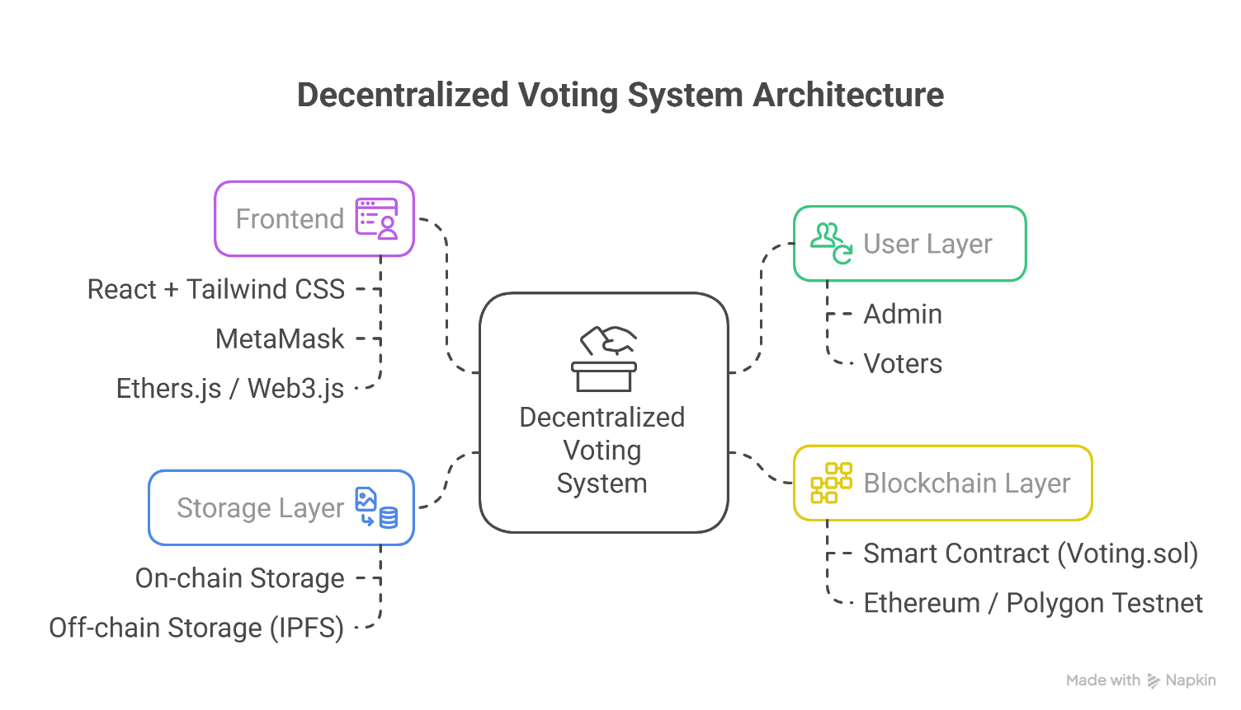
Fig. 5.1 Architecture Diagram

6.

System

Specifications

  - Hardware Requirements

Component | Minimum Specification | Recommended Specification
Processor | Intel i3 or equivalent | Intel i5/i7 or equivalent
RAM | 4 GB | 8 GB or higher
Storage | 10 GB free space | 20 GB SSD or higher
Internet | Stable broadband connection | High-speed broadband
GPU | Not required | Optional for faster browser rendering

  - Software Requirements

Category | Specification
Operating System | Windows 10 / macOS / Linux
Frontend Framework | React.js with Tailwind CSS
Smart Contract Language | Solidity
Blockchain Network | Ethereum (or Polygon Testnet for deployment)
Blockchain Client | MetaMask or other Web3-compatible wallet
IDE / Editor | Visual Studio Code
Node.js | Version 18+
Package Manager | npm or yarn
Blockchain Testing Environment | Hardhat or Truffle
Web3 Library | Ethers.js or Web3.js

7.

Results

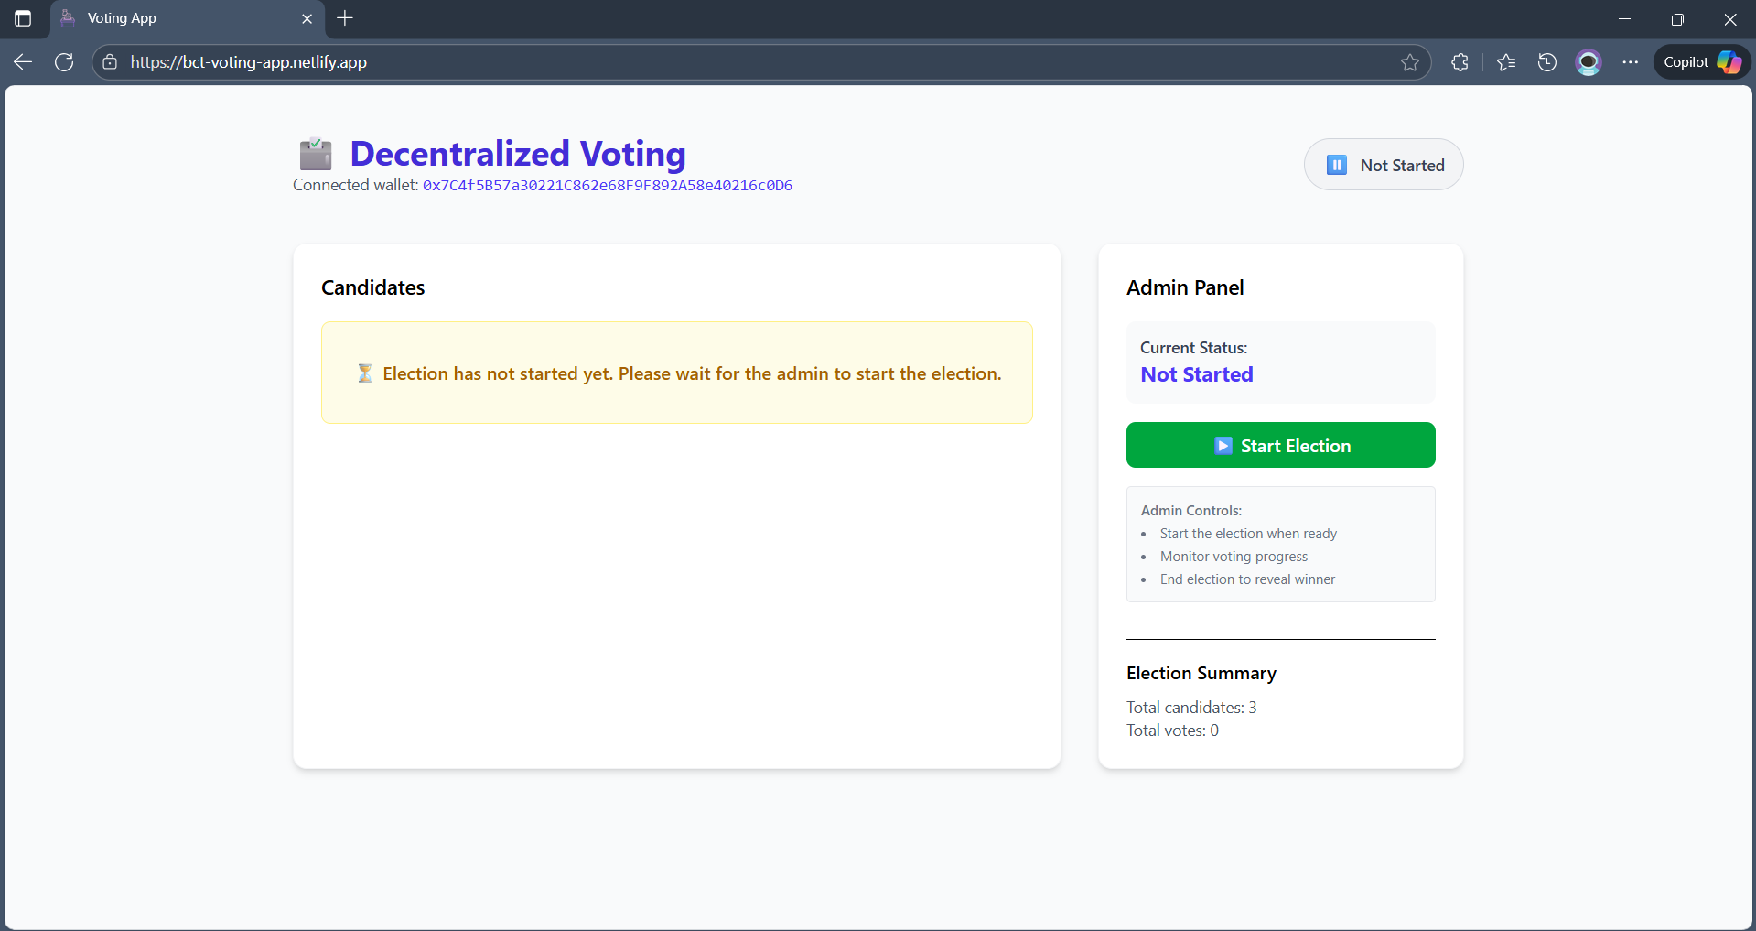
Fig: 7.1 Admin Dashboard
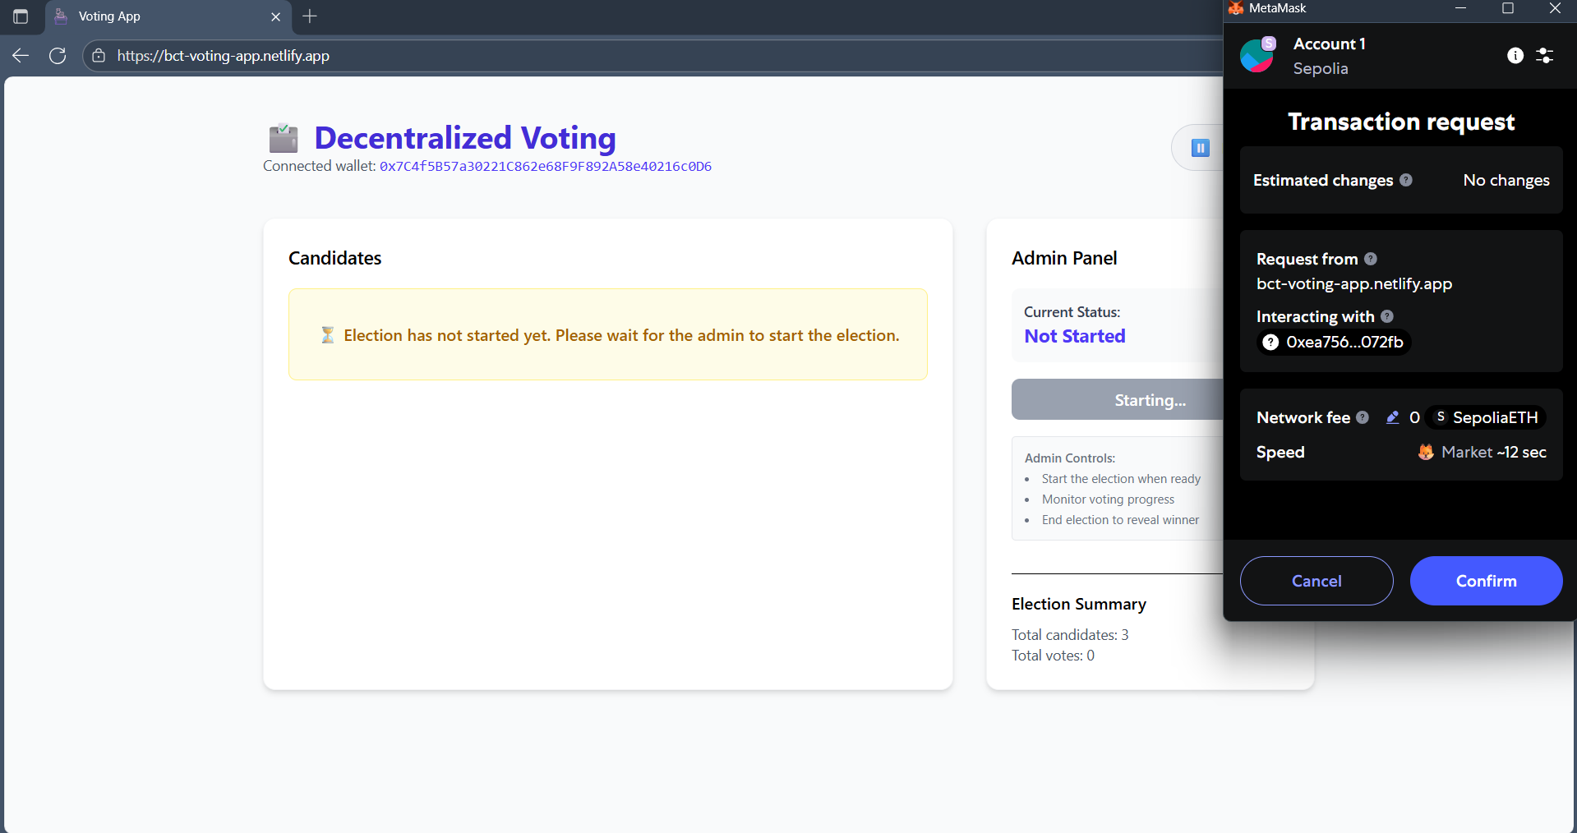
Fig. 7.2: Start Election
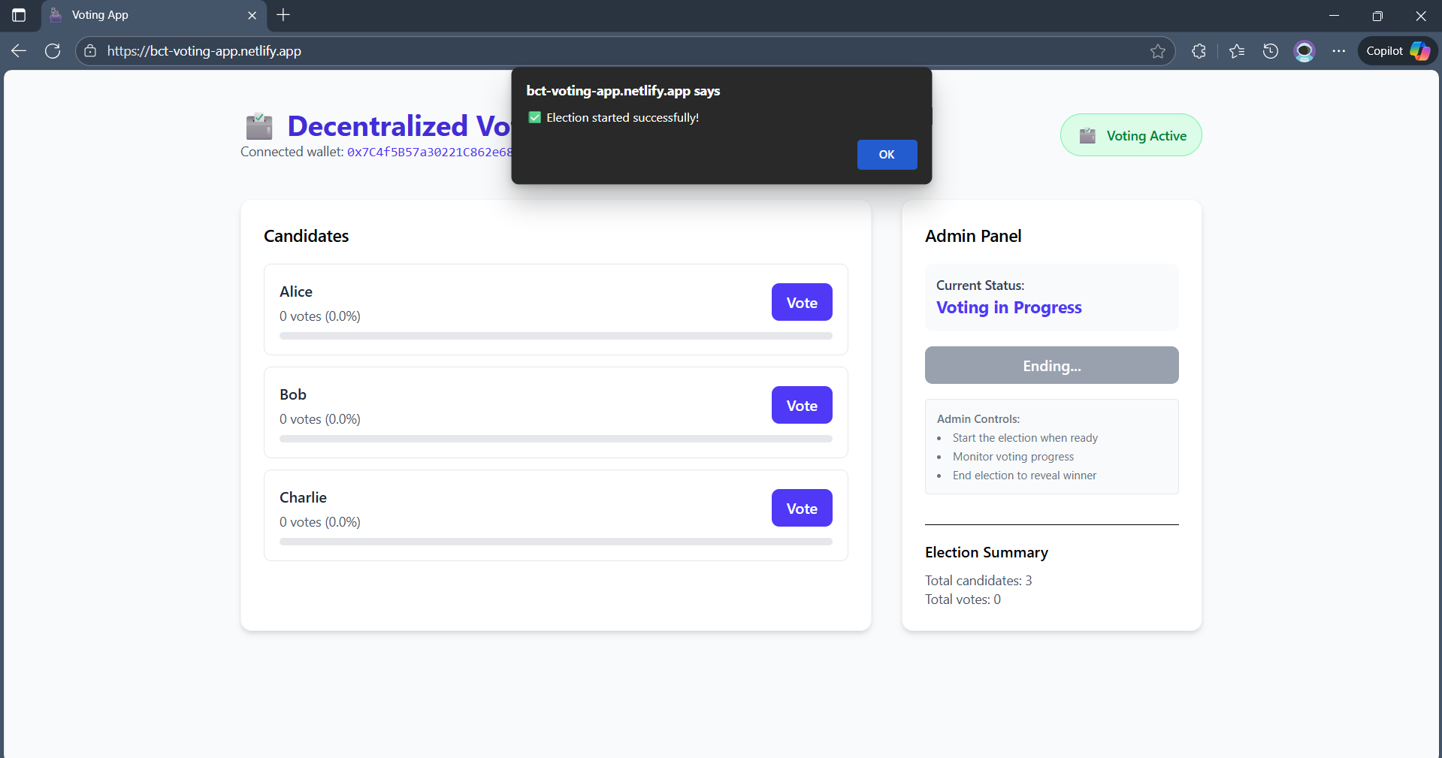
Fig: 7.3: Election Started
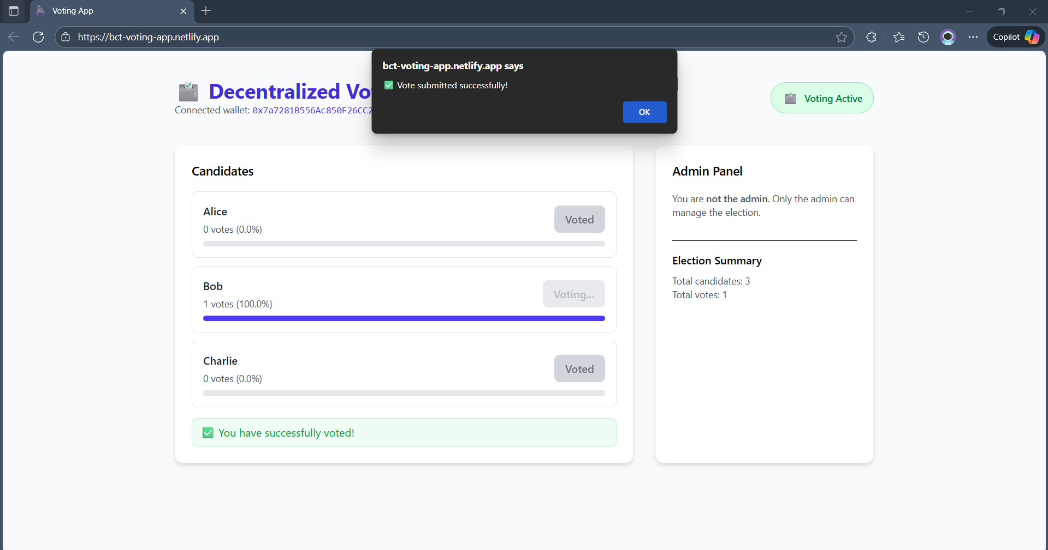
Fig: 7.4 Voter Dashboard

8.

Conclusion

The Decentralized Voting Application provides a secure, transparent, and efficient platform for conducting elections using blockchain technology. By leveraging smart contracts on the Ethereum network, the system ensures that votes are immutable, verifiable, and resistant to manipulation. The integration of a React.js frontend with Tailwind CSS offers a user-friendly interface, enabling voters to cast votes easily and administrators to manage the election seamlessly.
This project addresses the limitations of traditional voting systems, including manual errors, lack of transparency, and susceptibility to fraud. The application demonstrates the practical use of Web3 technologies, smart contract programming in Solidity, and real-time frontend-backend integration. It also showcases the importance of access control, event-driven architecture, and decentralized data management.
Overall, this decentralized voting system serves as a scalable prototype for secure electoral processes, providing a foundation for further enhancements such as multi-election support, advanced analytics, voter identity verification, and deployment on public blockchain networks. The project reinforces hands-on experience in blockchain development, decentralized application architecture, and modern web technologies.

9.

References

- Solidity Documentation. https://docs.soliditylang.org/
- Ethers.js Documentation. https://docs.ethers.io/
- React Documentation. https://reactjs.org/docs/getting-started.html
- Tailwind CSS Documentation. https://tailwindcss.com/docs
- MetaMask Documentation. https://metamask.io/

